COMPANION ROBOT

ABHISHEK KHANNA
ESHITA SHUKLA
SUYASH PRADHAN
AJAY BANKHELE

MECHANICAL DEPARTMENT
SRA VJTI MUMBAI-400019

khannaa153@gmail.com: 8652699015
suyash16999@gmail.com: 8108547999

TABLE OF CONTENTS

NO. TITLE PAGE NO.

ABSTRACT 3
1. INTRODUCTION 4
1.1. Technical Background 4
1.2. Proposed Solution 6
2. IMPLEMENTATION 6
3. RESULT 8
4. CONCLUSION 9
5. REFERENCES 9

ABSTRACT

Any dog owner knows how special a bond between Dog and Man can be. He’s your best friend, and you are his. But even the best of friends sometimes have to spend time apart. And when you go out into the world, you interact with other friends and colleagues, but your best friend spends much of his time missing you. Thus, we have proposed the concept of a companion bot to assist the pet and people when they are alone at home. The proposed concept serves as the middle person to feed, detect, entertain, play and communicate between the owner and the pet. A part of a home automation system is also implemented to assist people and make them control the lighting of a room as well as other electrical appliances in a simplified way. The Robot in this project was developed using a customized AT-MEGA 16 board, Arduino-Uno and Raspberry Pi-3.

INTRODUCTION

Technical Background

- Graphic User Interface(GUI)

Python provides various options for developing graphical user interfaces (GUIs). Tkinter is the standard GUI library for Python. GUIs often use a form of OO programming which we call event-driven: the program responds to events, which are actions that a user takes. Tkinter is the Python interface to the Tk GUI toolkit shipped with Python. Python when combined with Tkinter provides a fast and easy way to create GUI applications. Tkinter provides a powerful object-oriented interface to the Tk GUI toolkit. Tkinter provides us with a variety of common GUI elements which we can use to build our interface – such as buttons, menus and various kinds of entry fields and display areas. [1]

- Speech-Text Interface

For converting speech to text, an application programming interface (API) is required. Dialogflow (formerly Api.ai, Speaktoit) is a Google-owned developer of human–computer interaction technologies based on natural language conversations. Using Dialogflow users have new and engaging ways to interact with a product using both voice recognition and text input. It works on natural language processing and backed by Machine Learning. Dialogflow is backed by Google and runs on Google infrastructure, which means you can scale to millions of users. [4]

- Motor Drivers

A motor driver is a little current amplifier; the function of motor drivers is to take a low-current control signal and then turn it into a higher-current signal that can drive a motor. L298N is a solid, efficient H-Bridge motor driver. The enable pins are something which require some attention. The enable pins are something which require a
bit of attention, They can either be shorted with the 5V micro-controller output or
given a PWM signal by removing the connector cap and attaching the jumper to the
PWM pin.

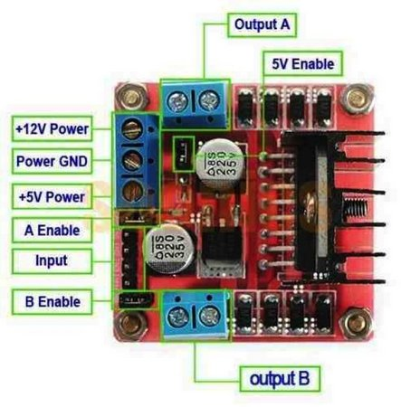

- Raspberry Pi 3 Micro-computer Board

The Raspberry Pi is a series of small single-board computers developed in the United Kingdom by the Raspberry Pi Foundation. Several generations of Raspberry Pis have been released. All models feature a Broadcom system on a chip (SoC) with an integrated ARM compatible central processing unit (CPU) and on-chip graphics processing unit (GPU). Processor speed ranges from 700 MHz to 1.4 GHz for the Pi 3 Model B+; on-board memory ranges from 256 MB to 1 GB RAM. Secure Digital (SD) cards are used to store the operating system and program memory in either SDHC or MicroSDHC sizes. Raspberry Pi 3 Model B was released in February 2016 with a 64 bit quad core processor, and has on-board WiFi, Bluetooth and USB boot capabilities. [3]

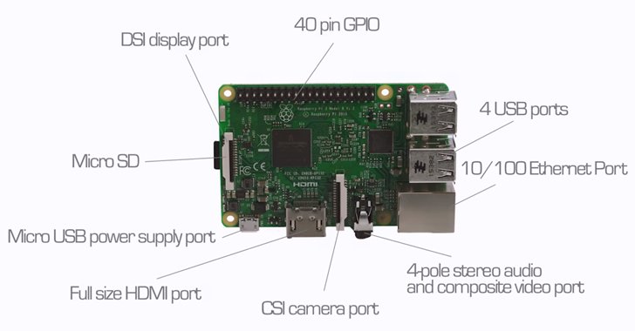

Proposed Solution

We proposed to make a 2-level bot in order to take care of the pet and senior citizens. The lower level would comprise of a food dispensing box, 2 motor drivers, AT-Mega 16 development board and Raspberry Pi 3 microcomputer board. At regular intervals, treats will be dispensed for the pet through the food box. The upper level would comprise of a ball shooting mechanism which would entertain the pet when it is alone at home. It is designed such that it will launch plastic ball which the pet can fetch. If the pet is trained properly, he will keep the ball back onto the tray at the top for it to be launched again. The implementation of the code for the motion and mechanisms is done using the Arduino IDE in C++. A Graphic User Interface(GUI) application is designed in order to control both these mechanisms. Its purpose is also for controlled motion of the bot in different directions. While designing a bot to assist the pet alone at home, we also decided to include some part of home automation in our GUI application. The user will have control over different electronic appliances at another location after getting access through this GUI application.

IMPLEMENTATION

The basic framework of our robot was made of aluminium rods. We initially started with the dimensions 45cm * 40cm * 40 cm. But as we made further progress in our work, we realised that the structure of a bot should be as compact as possible. Even after taking into consideration ball shooting mechanism, food dispensing mechanism and all the electronic components and wiring the bot would still be left with extra space. So, we decided to reduce the dimensions to 45cm * 35cm * 33cm.

Ball Shooting Mechanism

First we took two wheels, then attached some kind of grip on it. Fixed two motors of 500 rpm to their center and connected them in such a way that one runs clockwise and other in opposite direction. We set up a stand for them. We made two holes in the stand from where we could attach the wheels and motor. The two wheels should be at the distance slightly less than that of the diameter of the ball so the ball can squeeze between them. But after testing, we observed that the range travelled by the ball was very less. Using higher rpm motors was neither cost-friendly nor efficient as the padding on the wheels would begin to tear off after implementing the mechanism multiple times. So we decided to go in for a more efficient mechanism.
Then we opted for a ball shooting technique using an extension spring. The mechanism comprises of a 10 rpm motor and two aluminium box shaped rods placed one above the other. The lower rod is the shorter one and the upper one is supposed to hit the ball and can rotate freely about a dummy shaft attached to the lower rod. The upper rod has an extension spring attached to a fixed end. When we press the button designed for ball shooting, the mechanism starts and the motor begins to operate. This provides rotation to both the rods. We have inserted a long screw through the upper rod. During the free rotation of the upper rod, the screw gets stuck in the lower rod and both rods begin to move together. The spring begins to extend and at a point of time it reaches its maximum extension. At this moment, the upper rod freely rotates with a large angular velocity and gives an impulsive force to the ball placed on the tray.
Food Dispensing Mechanism
For the food dispenser, we placed a cardboard box on the lower level of the bot facing towards the front side. We made a flap in the front using a cardboard piece attached to a servo motor of low torque (about 1.5 kg-cm). The front portion of the box having the flap serves as both the inlet and outlet for the food. Initially, we were going to keep the box in a fixed position and attach an inlet at the top of the box. But after trial, we observed that while closing the flap, the treats at the opening would obstruct the flap. Hence we decided to allow the box to rotate. Another servo motor of high torque (about 3 kg-cm) is attached to the box and a rotational axis is provided using an aluminium rod. In the GUI application we have designed two buttons-refill food and dispense food. When we have to dispense food for the pet, the box will rotate about the axis provided such that the outlet is facing downwards. Then the flap designed will open with the help of the low torque servo motor and release the treats for the pet. After a specified period of time, the flap will close and the box will rotate using the high torque servo motor and return to its original position where the flap is facing upwards. Now, whenever the user wants to insert food, he can use the refill food button, the flap will open and the owner can easily add some food for the pet.

Home Automation
We made use of the extensive libraries provided by python 3. A local server was developed using the module flask. [2] First of all, a person has to be registered in order to get access to this page. By importing an in-built module Tkinter, we have designed multiple windows running in a loop. First window is the one which controls the bot and its mechanisms. It also has two more buttons-Log In and Register. On pressing Register, another window will open which will allow a new user to register by allowing him to decide his username and password. After successful registration, that user can access the page by selecting the button Log In. This will take him to a third window where he will have to enter his username and password. Now with the help of file handling, entered details are verified and registered users will be given access to the page. This page will also use file handling in order to control the electronic appliances in a room. There are two columns-one will describe the name of the appliance and the other will notify the user of its status. The user has the freedom to not only power the appliances but also to add new appliances to the list. The changed status of the pins is observed by connecting LED’s to the Arduino-Uno board.
All connections for the motors are done on AT-Mega 16 board with the help of 2 motor drivers(L-298) as we have used 5 Johnson Motors(4 for the wheels having 200 rpm and 1 for ball shooter of 10 rpm). For connecting the two servo motors, we had to make a parallel circuit of three voltage regulators(7805) on a matrix board and connect it to the At-Mega 16 board.

Result
The end result of the project the implementation of the ball shooter, food dispenser, GUI application and the home automation system. A plastic ball was shot using the ball shooter which showed a shooting range of around 1.3 m. The food dispenser was tested by using it to serve chocos for a definite period of time and to refill it. The bot is given commands through the GUI application to navigate in different directions. The commands are given wirelessly from the computer to Raspberry Pi 3 board (using Wi-Fi), which communicates it to the AT-Mega 16 board which eventually controls the bot and its mechanisms.

Conclusion
We observed that all the mechanisms designed and GUI applications developed works smoothly. A camera can also be placed at the front of the bot so that the owner can view the pet and a LCD screen can be placed through which the pet can also communicate with the owner. We tried connecting a Pi-Cam and begin writing the code for video streaming but due to technical issues, non-compatibility of Raspberry Pi 3 and the cameras and limited time to complete the project it was not possible. We also tried to introduce a speech to text interface in the home automation system using an Application Programming Interface(API)-DialogFlow by which the user can orally give commands to control the lighting of the room, the speech will be converted to text and the task will be performed. Therefore, by adding such additional features to our bot, it can truly serve as a companion to a pet as well as assist humans in today’s hectic life.

References

[1] http://python-textbok.readthedocs.io/en/1.0/Introduction_to_GUI_Programming.html
[2] https://www.tutorialspoint.com/flask/index.html
[3] https://en.wikipedia.org/wiki/Raspberry_Pi
[4] https://github.com/dialogflow

